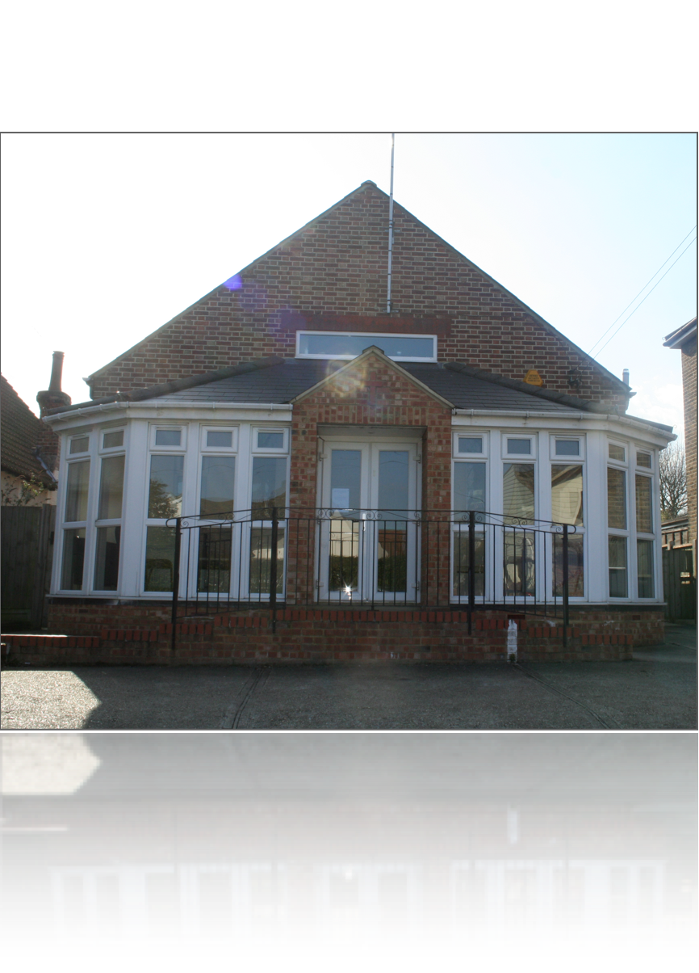

Our Fundamental Beliefs

28. The New Earth
27. The Millennium and the End of Sin
26. Death and Resurrection
25 The Second Coming of Christ
24. Christ's Ministry in the Heavenly Sanctuary
23. Marriage and the Family
22. Christian Behaviour
21. Stewardship
20. The Sabbath
19. The Law of God
18. The Gift of Prophecy
17. Spiritual Gifts and Ministries
15. Baptism
14. Unity in the Body of Christ
13 The Remnant and Its Mission
12 The Church
10. The Experience of Salvation
9. The Life Death And Resurrection of Christ
8. The Great Controversy
7. The Nature of Man
6. Creation
5. God The Holy Spirit
4. God The Son
3. God The Father
2. The Godhead
1. The Word of God

WELCOME
ONE AND ALL TO
Basildon District

D
SEVENTH-DAY ADVENTIST CHURCH
Sabbath 10th August 2013
Address:
17 Jersey Gardens,
Wickford SS11 7AG
More Info
www.basildonsdachurch.org.uk
communication@basildonsdachurch.org.uk
† Services ¢
Sabbath School: 09:30a.m.
Divine Service: 11:15a.m.
AYS/Bible Study: 3:00p.m.
Accepted vs Rejected
Pastor John Melki

Pastor  Head Elder | J. Melki  T. Waldron | 07803829790  07956067485
Elders | E. Oluikpe  O. Skerritt | 07896565913  07956876153
Personal Mins  Head Deacon  Head Deaconess  Church Clerk  Sabbath School  Children’ Mins  Youth  Music Director  Media  Women’s Mins  Men’s Mins  AMR  Pathfinders  Interest Co-  Prayer Ministry  Stewardship  Communications  CSR  Community Serv.  Health Ministry  Prision Ministry | P. Mbano  J. Jackman  L. Chikwanha  M. Skerritt  A. Oluikpe  G. Harrison  J. Jackman  O. Skerritt  O. Skerritt  I. Charidza  E. Oluikpe  S. Jackman  K. Waldron  E. Babafemi  S. Jackman  E. Oluikpe  M. Skerritt  P. Mangena  M. Sabadin  N. Nhliziyo  V. Jere | 07809151964  07951770754  07429693007  07771535999  07546968476  01268530191  07951770754  07956876153  07956876153  07957482603  07896565913  07853029696  07904197510  07535351666  07853029696  07896565913  07956876153  07707041832  07966293791  07931226320  07887503133

ANNOUNCEMENTS
Everyone is welcome to stay for fellowship lunch today.
This afternoon’s programme will be presented by the Male Voice Choir at 3.00pm.
Friday Vespers
Time: 7.00pm Venue: 17 Jersey Gardens
Church Excursion - 25 August 2013
The proposed venue for our Church Excursion is Dove Dale in the Peak District. Alternatively, we can visit the Epping Forest area or the Maldon Area. Should you have any further venue ideas please speak to Bro Tyronne. We must finalise a venue in the coming week or two.
Choir Practice – Wednesday at 8.00pm.
School of Evangelism
22 September to 15 June 2013/14 Please see the church website or notice board for more information on Health Ministries courses and the SEC Evangelism Course, and to obtain an application form.
Prayer Ministries Department
The Intercessory Prayer Group will meet on Tuesday at 7.00pm at Sis Salisha's house.
BUC Women’s Ministries Retreat – “Women of Virtue”
18-20 October 2013 at the Orchard Hotel, University Park in Nottingham. More information can be found on the website, or speak to Sis Irene Charidza. Closing date for application is 30 September 2013.
SEC Single Adults' Retreat: 6-8 September 2013
More information can be found on the website. Closing date for application is 22 August 2013.
Please send your announcements to Marlene by Wednesday.
More announcements are available on the church website: www.basildon.adventistchurch.org.uk/announcements

Accepted vs Rejected
Introit
Father we love you, we worship and adore you,
Glorify thy name in all the earth,
Glorify thy name, glorify thy name,
Glorify thy name in all the earth.
Hymn No. 694
Praise God from whom all blessings flow,
Praise Him all creatures here below,
Praise Him above, ye heavenly host,
Praise Father, Son, and Holy Ghost.
Hymn No. 684
Hear our prayer, O Lord,
Hear our prayer, O Lord,
Incline thine ear to us,
And grant us Thy peace. Amen.
Let There be Love Shared Among Us.
Let there be love shared among us,
Let there be love in our eyes,
May now your love sweep this nation,
Cause us O Lord to arise.
Give us a fresh Understanding
Of brotherly love that is real,
Let there be love shared among us,
Let there be love.
Call To Worship
L: The LORD is my light and my salvation; whom shall I fear?
P: The LORD is the stronghold of my life; of whom shall I be afraid?
L: One thing I asked of the LORD, that will I seek after:
P: To behold the beauty of the LORD, and to inquire in his temple.
L: "Come," my heart says, "seek his face!"
P: Your face, LORD, do I seek.
L: O Lord God of our salvation, we worship and adore you,
P: We will sing your praises for ever and ever. Amen!
Divine Service
Announcements: Sis. Marlene Skerritt
Call to worship: Eld. Emeka Oluikpe
Introit: “Father we love You”
Invocation: Pastor John Melki
Doxology: Hymn 694
Welcome: Eld. Emeka Oluikpe
Opening Hymn: Eld. Emeka Oluikpe
470: “There’s sunshine in my soul today”
Scripture reading: Matthew 7:21 - 23
Children’s story: Bro Junior Jackman
Tithes and Offerings: Sis Joyce Magiya
Garden of Prayer: Sis Natasha Briscoe
Prayer Response: Hymn 684
Praise and Worship: Praise Team
Special Item:
Sermon: Pastor John Melki
“Accepted vs Rejected”
Closing Hymn: Eld. Emeka Oluikpe
370: “Christ for the world”
Benediction: Pastor John Melki
Postlude: “Let there be love…”

