|  |  |  |
| --- | --- | --- |
| **Pastor Head** **Elder** | **J. Melki E. Oluikpe** | **07803829790 07896565913** |
| **Elders** | **M. Sabadin O. Skerritt** | **07707041832 07956876153** |
| **Personal Ministry**  **Head Deacon**  **Head Deaconess**  **Church Clerk**  **Sabbath School**  **Children’s Ministry**  **Youth**  **Music Ministry**  **Media**  **Women’s Ministry**  **Men’s Ministry**  **AMR**  **Pathfinders**  **Publishing**  **Prayer Ministry**  **Stewardship**  **Communications**  **KCFS**  **Family Ministry**  **Community Serv.**  **Health Ministry**  **Hospitality** | Emeka Oluikpe  O. Skerritt  L. Chikwanha  Ajithra Praveen  Abiola Oluikpe  G. Harrison  J. Jackman  G. Mkwanazi  O. Skerritt  P. Mangena  Attila Matyus  S. Jackman  Suko Sibanda  P. Mbano  Suko Sibanda  Roda Williams  M. Skerritt  Noe Dube  S. Jackman  M. Sabadin  G. Mkwanazi  M. Gibbard | 07896565913  07956876153  07429693007  07403244503  07546968476  01268530191  07951770754  07585783879  07956876153  07966293791  07916796989  07853029696  07944143994  07771535999  07944143994  07904368859  07771535999  07538589045  07853029696  07707041832  07585783879  07944250620 |

**ANNOUNCEMENT**

**HAPPY SABBATH!**

**There will be no fellowship lunch after the service. We urge you to have your lunch at your homes, and return for the program @ 7pm prompt.**

**Wednesday Prayer Meeting**

Time: 7.00pm Presenter: TBA

Topic: TBA

**Friday Vespers**

Time: 7.30pm Presenter: The Publishing Team

**Choir practice**  
Today after the service

**Upcoming Special Sabbaths**

Children’s Day – 30 September

**Half night prayer meeting**  
This evening Theme: The Two Beasts and Eight Kings of Revelation 13-17 Presenter: Pastor Sydney Almeida

**Church Cleaning**

Sunday 1 October 10.00am

**The Library**

If you would like to borrow a book from the library please see Sis Paula or Sis Marlene.

**Membership Transfer**

If you would like to move your membership, please speak to the Church Clerk.

**EMERGENCY PROCEDURE**

Know where the fire exits are. Know where the fire assembly point is. Know the fire action procedure.

Email – [communication@basildonsdachurch.org.uk](mailto:communication@basildonsdachurch.org.uk)

Sabbath 23 September 2017

Sunset Today: 18:53

**Total Member Involvement (TMI)**

S

2015

SEVENTH-DAY ADVENTIST CHURCH

ONE AND ALL TO

Basildon District

D

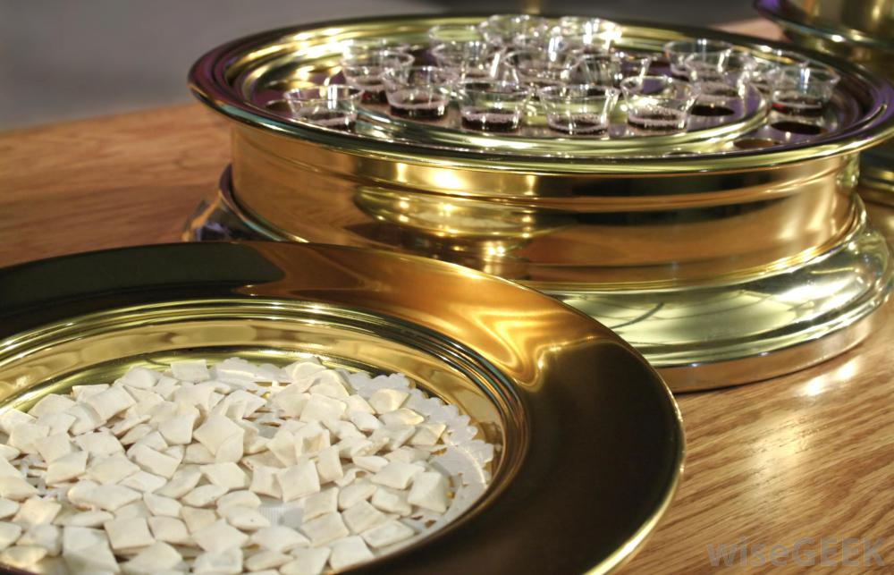

**Who do you think is your God?**

**† Services** **¢**  
Sabbath School: 09:30a.m.  
Divine Service: 11:15a.m.  
 AYS/Bible Study: 3:30p.m.

**WELCOME**

Address:   
17 Jersey Gardens,  
Wickford  SS11 7AG

More Info  
[www.basildonsdachurch.org.uk](http://www.basildonsdachurch.org.uk)  
[communication@basildonsdachurch.org.uk](mailto:communication@basildonsdachurch.org.uk)

**Pastor John Melki**

**Pastoral Information**

**Please tick if you desire any of the following and give this slip to an Elder or a Deacon.**

* **I desire to unite with the church**
* **I desire baptism**
* **I desire a pastoral visit**
* **I desire to have bible study**
* **I need special prayer**
* **I desire a baby blessing for my child**

**Name: ………………………………………………**

**Address: ……………………………………………**

**………………………………………………………..**

**Telephone: …………………………………………**

**E-mail: ………………………………………………**

**Sabbath School**

**Devotion:** Sis Grace

**Opening Hymn:** #476

**Opening Prayer**: Youth

**Lesson study remarks:** Sis Abigail

**Lesson Study Class:** Pastor Melki

**Final thoughts:** Sis Abigail

**Adventist Mission/Offering:** DVD

**Closing Hymn:** #505

**Closing Prayer:** Youth

**10mins Spot/Interlude:** Book Review

**60SEC**

**Introit**Surely, the presence of the Lord is in this place  
I can feel His might power and His grace  
I can hear the brush of angels’ wings  
I see glory on each face  
Surely, the presence of the Lord is in this place.

**Doxology**  
I will come and bow down at your feet Lord Jesus  
In Your presence is fullness of joy  
There is nothing, there is no one who compares with You  
I take pleasure in worshipping you Lord.

**Psalm 5**  
Give ear to my words O Lord  
Consider my meditation  
Hearken unto the voice of my cry  
My King and my God  
For unto Thee will I pray  
My voice shalt thou hear in the morning  
O Lord in the morning will I direct my prayer  
Unto Thee and will look up.

**Be Magnified, O Lord**  
I have made you too small in my eyes  
O Lord, forgive me  
And I have believed in a lie  
That you were unable to help me  
But now, O Lord, I see my wrong  
Heal my heart and show yourself strong  
And in my eyes, and with my song  
O Lord be magnified, O Lord be magnified.

***Chorus***  
Be magnified O Lord  
You are highly exalted  
And there is nothing you can’t do  
O Lord, my eyes are on you, be magnified  
O Lord be magnified, O Lord be magnified.

**Divine Service**

**Announcements:** *Sis. Nola Townsend*

**Praise and Worship:** *Praise Team*

**Introit:** *Surely the presence of the Lord...*

**Call to worship:** *Elder Marc Sabadin***Invocation:** Pastor J Melki

**Doxology:** *I will come and bow down...*

**Welcome:** *Elder Marc Sabadin***Opening Hymn:**  *#86*

*“How Great Thou Art”*

**Tithes and Offerings:** *Sis Lizzie Chikwanha*

**Garden of Prayer:** *Sis Grace Mkwanazi***Prayer Response:** *Psalm 5*

**Scripture reading:** *Isaiah 40:25 – 26*

**Special Item:** *Basildon Choir*

**Sermonette: Pastor J Melki  
 *“Who Do You Think Your God Is?”***

**Hymn of Separation:** #159  
*“The Old Rugged Cross”*

**Washing of feet – Partakers**

**Children’s story:** Junicia Jackman

**Who Do You Think Your God Is?**